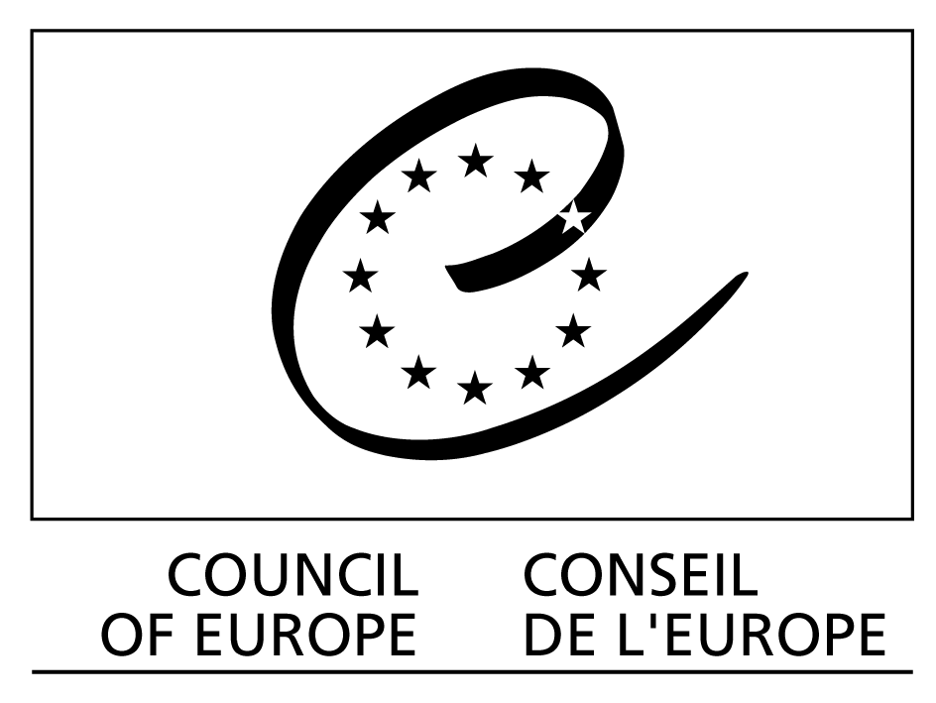

European Treaty Series - No. 178

EUROPEAN CONVENTION
ON THE LEGAL PROTECTION
OF SERVICES BASED ON,
OR CONSISTING OF,
CONDITIONAL ACCESS

Strasbourg, 24.I.2001

Preamble

The member States of the Council of Europe, other States and the European Community signatory hereto,

Considering that the aim of the Council of Europe is to achieve a greater unity between its members;

Bearing in mind Recommendation No. R (91) 14 of the Committee of Ministers on the legal protection of encrypted television services;

Considering that piracy of decoding equipment for encrypted services is still a problem throughout Europe;

Noting that new types of conditional access services and devices, as well as new forms of unlawful access to these, have appeared since the adoption of the above recommendation;

Noting that there is great disparity among European States on legislation aimed at protecting services based on, or consisting of, conditional access;

Noting that unlawful access threatens the economic viability of the organisations providing broadcasting and information society services and, in consequence, may affect the diversity of programmes and services offered to the public;

Convinced of the need to pursue a common policy aimed at the protection of services based on, or consisting of, conditional access;

Convinced that criminal, administrative or other sanctions can play an effective role in the prevention of unlawful activities against conditional access services;

Believing that particular attention should be given to illicit activities that are undertaken for commercial purposes;

Taking account of existing international instruments which contain provisions aiming at the protection of services based on, or consisting of, conditional access,

Have agreed as follows:

Section I – General provisions

Article 1 – Object and purpose

This Convention is concerned with broadcasting and information society services offered against payment and based on, or which consist of, conditional access. The purpose of this Convention is to make illegal on the territory of the Parties a number of activities which give unauthorised access to protected services, and to approximate the legislation of Parties in this area.

Article 2 – Definitions

For the purposes of this Convention:

a “protected service” means any of the following services, when provided against remuneration and on the basis of conditional access:

– television programme services, as defined in Article 2 of the amended European Convention on Transfrontier Television;

– radio broadcasting services, meaning radio programmes intended for reception by the public, transmitted by wire or over the air, including by satellite;

– information society services, understood as those offered by electronic means, at a distance and at the individual request of a recipient of services;

or the provision of conditional access to the above services considered as a service in its own right;

b “conditional access” means any technical measure and/or arrangement permitting access in an intelligible form, and subject to prior individual authorisation, to one of the services mentioned in paragraph a. of this article;

c “conditional access device” means any equipment, software and/or arrangement designed or adapted to give access in an intelligible form to one of the services mentioned in paragraph a. of this article;

d “illicit device” means any equipment, software and/or arrangement designed or adapted to give access in an intelligible form to one of the services mentioned in paragraph a. of this article, without the authorisation of the service provider.

Article 3 – Beneficiaries

This Convention shall apply to any legal or natural persons offering a protected service as defined in Article 2.a above, regardless of their nationality and whether or not they come under the jurisdiction of a Party.

Section II – Illicit activities

Article 4 – Offences

It shall be unlawful to carry out one of the following activities on the territory of a Party:

a the manufacture or production of illicit devices for commercial purposes;

b the importation of illicit devices for commercial purposes;

c the distribution of illicit devices for commercial purposes;

d the sale or rental of illicit devices for commercial purposes;

e the possession of illicit devices for commercial purposes;

f the installation, maintenance or replacement of illicit devices for commercial purposes;

g the commercial promotion, marketing or advertising of illicit devices.

Each Party may, at any time, in a declaration addressed to the Secretary General of the Council of Europe, declare that it will also make unlawful other activities than those referred to in paragraph 1 of this article.

Section III – Sanctions and remedies

Article 5 – Sanctions for unlawful activities

The Parties shall adopt measures to make the unlawful activities established in Article 4 above punishable by criminal, administrative or other sanctions. Such measures shall be effective, dissuasive and proportionate to the potential impact of the unlawful activity.

Article 6 – Confiscation measures

The Parties shall adopt such appropriate measures as may be necessary to enable it to seize and confiscate illicit devices or the promotional, marketing or advertising material used in the commission of an offence, as well as the forfeiture of any profits or financial gains resulting from the unlawful activity.

Article 7 – Civil proceedings

The Parties shall adopt the necessary measures to ensure that providers of protected services whose interests are affected by an unlawful activity established in Article 4 above have access to appropriate remedies, including bringing an action for damages and obtaining an injunction or other preventive measure, and where appropriate, applying for the elimination of illicit devices from commercial channels.

Section IV – Implementation and amendments

Article 8 – International co-operation

The Parties undertake to render each other mutual assistance in order to implement this Convention. The Parties shall afford each other, in accordance with the provisions of relevant international instruments on international co-operation in criminal or administrative matters and with their domestic law, the widest measure of co-operation in investigations and judicial proceedings relating to criminal or administrative offences established in accordance with this Convention.

Article 9 – Multilateral consultations

1 The Parties shall, within two years from the entry into force of this Convention and every two years thereafter, and, in any event, whenever a Party so requests, hold multilateral consultations within the Council of Europe to examine the application of this Convention and the advisability of extending or revising any of its provisions, in particular as regards the definitions under Article 2. These consultations shall take place at meetings convened by the Secretary General of the Council of Europe.

2 Each Party may be represented at multilateral consultation meetings by one or more delegates. Each Party shall have the right to vote. Each State Party to this Convention shall have one vote. Concerning questions within its competence, the European Community shall exercise its right to vote and cast a number of votes equal to the number of its member States that are Parties to the Convention. The European Community shall not exercise its right to vote when the vote concerns a question which does not fall within its competence.

3 Any State referred to in Article 12, paragraph 1, or the European Community, which is not a Party to this Convention, may be represented in the consultation meetings by an observer.

4 After each consultation, the Parties shall forward to the Committee of Ministers of the Council of Europe a report on the consultation and on the functioning of the Convention, including, if it is considered necessary, proposals for the amendment of the Convention.

5 Subject to the provisions of this Convention, the Parties shall lay down rules of procedure for the consultation meetings.

Article 10 – Amendments

1 Any Party may propose amendments to this Convention.

2 Any proposal for amendment shall be notified to the Secretary General of the Council of Europe who shall communicate it to the member States of the Council of Europe, to the other States Party to the European Cultural Convention, to the European Community and to any non-member State which has acceded to or has been invited to accede to this Convention in accordance with the provisions of Article 13.

3 Any amendment proposed in accordance with the provisions of the previous paragraph shall be examined, within six months from the date on which it is communicated by the Secretary General, at a multilateral consultation meeting, where that amendment can be adopted by a majority of two-thirds of the States which have ratified the Convention.

4 The text adopted by the multilateral consultation meeting shall be submitted to the Committee of Ministers for approval. Once it has been approved, the text of the amendment shall be forwarded to the Parties for acceptance.

5 All amendments shall enter into force on the thirtieth day after all the Parties have informed the Secretary General of their acceptance thereof.

6 On the basis of a recommendation by a multilateral consultation meeting, the Committee of Ministers may decide, by the majority provided for in Article 20.d of the Statute of the Council of Europe and by the unanimous vote of the representatives of the Parties entitled to sit on the Committee, that a particular amendment shall enter into force following the expiry of a period of two years after the date on which it has been forwarded for acceptance, unless a Party has notified the Secretary General of the Council of Europe of an objection to its entry into force. Should such an objection be notified, the amendment shall enter into force on the first day of the month following the date on which the Party to the Convention which has notified the objection has deposited its instrument of acceptance with the Secretary General of the Council of Europe.

7 If an amendment has been approved by the Committee of Ministers, but has not yet entered into force in accordance with paragraphs 5 or 6 above, a State or the European Community may not express their consent to be bound by the Convention without accepting at the same time the amendment.

Article 11 – Relationship with other conventions or agreements

1 This Convention does not affect the rights and undertakings derived from international multilateral conventions concerning special matters.

2 The Parties to the Convention may conclude bilateral or multilateral agreements with one another on the matters dealt with in this Convention, for purposes of supplementing or strengthening its provisions or facilitating the application of the principles embodied in it.

3 If two or more Parties have already concluded an agreement or treaty in respect of a subject which is dealt with in this Convention or otherwise have established their relations in respect of that subject, they shall be entitled to apply that agreement or treaty or to regulate those relations accordingly, in lieu of the present Convention, if it facilitates international co-operation.

4 In their mutual relations, Parties which are members of the European Community shall apply Community rules and shall not therefore apply the rules arising from this Convention except in so far as there is no Community rule governing the particular subject concerned.

Section V – Final clauses

Article 12 – Signature and entry into force

1 This Convention shall be open for signature by the member States of the Council of Europe and the other States party to the European Cultural Convention, and by the European Community. Such States and the European Community may express their consent to be bound by:

a signature without reservation as to ratification, acceptance or approval; or

b signature subject to ratification, acceptance or approval, followed by ratification, acceptance or approval.

2 Instruments of ratification, acceptance or approval shall be deposited with the Secretary General of the Council of Europe.

3 This Convention shall enter into force on the first day of the month following the expiration of a period of three months after the date on which three States have expressed their consent to be bound by the Convention in accordance with the provisions of the preceding paragraph.

4 In respect of any signatory State or the European Community which subsequently expresses its consent to be bound by it, the Convention shall enter into force on the first day of the month following the expiration of a period of three months after the date of the expression of its consent to be bound by the Convention in accordance with the provisions of paragraph 1.

Article 13 – Accession to the Convention by non-member States

1 After the entry into force of this Convention, the Committee of Ministers of the Council of Europe, after consulting the Parties to the Convention, may invite any State which is not referred to in Article 12, paragraph 1, to accede to this Convention, by a decision taken by the majority provided for in Article 20.d of the Statute of the Council of Europe and by the unanimous vote of the representatives of the Contracting States entitled to sit on the Committee.

2 In respect of any acceding State, the Convention shall enter into force on the first day of the month following the expiration of a period of three months after the date of deposit of the instrument of accession with the Secretary General of the Council of Europe.

Article 14 – Territorial application

1 Any State or the European Community may, at the time of signature or when depositing its instrument of ratification, acceptance, approval or accession, specify the territory or territories to which this Convention shall apply.

2 Any State or the European Community may, at any later date, by a declaration addressed to the Secretary General of the Council of Europe, extend the application of this Convention to any other territory specified in the declaration. In respect of such territory the Convention shall enter into force on the first day of the month following the expiration of a period of three months after the date of receipt of such declaration by the Secretary General.

3 Any declaration made under the two preceding paragraphs may, in respect of any territory specified in such declaration, be withdrawn by a notification addressed to the Secretary General of the Council of Europe. The withdrawal shall become effective on the first day of the month following the expiration of a period of three months after the date of receipt of such notification by the Secretary General.

Article 15 – Reservations

No reservation may be made to this Convention.

Article 16 – Settlement of disputes

In case of a dispute between Parties as to the interpretation or application of this Convention, the Parties concerned shall seek to achieve a friendly settlement of the dispute through negotiation or any other peaceful means of their choice, including submission of the dispute to an arbitral tribunal whose decisions shall be binding upon the Parties.

Article 17 – Denunciation

1 Any Party may, at any time, denounce this Convention by means of a notification addressed to the Secretary General of the Council of Europe.

2 Such denunciation shall become effective on the first day of the month following the expiration of a period of three months after the date of receipt of the notification by the Secretary General.

Article 18 – Notifications

The Secretary General of the Council of Europe shall notify the member States of the Council of Europe, the other States party to the European Cultural Convention, the European Community and any other State which has acceded to this Convention of:

a any signature in accordance with Article 12;

b the deposit of any instrument of ratification, acceptance, approval or accession in accordance with Articles 12 or 13;

c any date of entry into force of this Convention in accordance with Articles 12 and 13;

d any declaration made in accordance with Article 4;

e any proposal for amendment made under Article 10;

f any other act, notification or communication relating to this Convention.

In witness whereof the undersigned, being duly authorised thereto, have signed this Convention.

Done at Strasbourg, the 24th day of January 2001, in English and in French, both texts being equally authentic, in a single copy which shall be deposited in the archives of the Council of Europe. The Secretary General of the Council of Europe shall transmit certified copies to each member State of the Council of Europe, to the other States party to the European Cultural Convention, to the European Community and to any State invited to accede to it.

