Letter of Intent
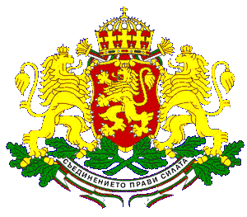
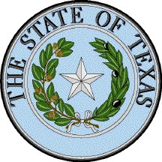
for the
Establishment
of
Friendly Relations
Between
The Republic of Bulgaria
And
The State of Texas

The Republic of Bulgaria and the State of Texas of the United States of America, desiring to strengthen cooperation, to deepen understanding and to promote friendship, believe it necessary to establish friendly relations and jointly agree upon the signing of this Letter of Intent for the Establishment of Friendly Relations between the Republic of Bulgaria and the State of Texas.

- In accord with this Letter of Intent and based upon goodwill, the spirit of equality and mutual benefit, both parties will actively encourage and promote the expansion of cooperation and exchange in the areas of trade, investment and tourism. Both parties will facilitate the spread of information about the corresponding partner thus helping to develop better mutual knowledge and people-to-people contacts.

- For the purpose of maintaining close contacts between the two signatories, the Embassy of the Republic of Bulgaria in the United States of America and the Office of the Secretary of State of the State of Texas are appointed respectively as the liaisons between the two signatories.

- The governments of the two sides shall support exchange in the above-mentioned areas as well as facilitate the exchange of delegation visits between the two signatories.

This Letter of Intent is signed by the two parties in expression of their willingness to work together toward mutually beneficial endeavors and does not commit either party to any legally binding terms, conditions and obligations. The Letter of Intent shall be valid until declared otherwise in writing by either party. The Letter of Intent is written in duplicate in the Bulgarian and the English languages, both texts being equally authentic. The Letter of Intent shall enter into force on the date of its signature.

This Letter of Intent is signed on the … , 2004 in Austin, Texas, USA.

The Honorable Solomon Passy The Honorable Geoffrey S. Connor
Minister of Foreign Affairs Secretary of State
Republic of Bulgaria The State of Texas
United States of America

