DONOR AGREEMENT
ANNEX 1

Country: BULGARIA
Ministry of Health
5, Sveta Nedelia Sq., Sofia
Implementing institution:
Ministry of Health
“Health Prophylaxis and State Sanitary Control” Directorate
39, Stamboliyski Blvd., Sofia
Title of Project:
“Strengthening Food Safety and Nutrition Services in SEE: Component One: Food Policy and Legislation”
Decision on Component One of 7th Meeting of SEE Health Network, Tirana, Albania, November 2003 and signed by the nominated representatives the eight SEE beneficieries countries, specified below, Greece, Council of Europe and WHO Regional Office for Europe at the 7th Meeting of the Stability Pact Initiative for Social Cohesion, Brussels, Belgium, 8 December 2003.
Justification:
Food safety and the surveillance and control of food borne and diet related diseses is a state responsibility in the SEE countries and was well functioning for decades, but since the countries are in transition to market economy this systems has to be adapted to the modern preventive approach concept. The SEE countries have enormous food trade potential and, also, they have potential for further development of their agricultural, food processing and tourism sectors, in addition to improving public health.

Project Objective:
To strengthen the institutional capacity of the public and private components of the health system to achieve the objectives of decreasing the food-borne and diet related diseases through control and prevention at central, regional and local levels with an inter-country and intersectoral approach.

Project outcomes (deliverables) :
Through regional ( inter-country) and national activities each SEE will achieve the following:

- Assessment of food and nutrition status of the country (country profile)
- Development of National Food and Nutrition Policy and Action Plan (new or revised)
- Draft Food Safety Strategy
- Drafts of Food Laws or revision of existing ones
- Participation in a regional network
- Enhanced national capacities in the area of food safety
- Raising awareness of food and nutrition as an important value of the community with major social and economic implications

The above outcomes of the Project will contribute toward:

- Improving food safety and nutrition of the countries' population
- Support the development of the agricultural, food processing, trade and tourism sectors, and
- Promoting social cohesion, reconciliation and stability within the region

Geographical focus: South Eastern Europe (SEE)
Country(ies): Albania
Bosnia and Herzegovina
Bulgaria
Croatia
Republic of Moldova
Romania
Serbia and Montenegro, and
The Former Yugoslav Republic of Macedonia

Project Implementation Dates:

Starting Date: 01 November 2004
Completion Date: 01 November 2005

Budget:

The total budget for the component one is € 356.684 provided by the following donors:

Greece: | 150.000 Euro
Italy: | 105.000 Euro
Switzerland: | 43.000 Euro
WHO: | 58.684 Euro

The total amount of € 356.684 is shared equally by the eight beneficiary countries.

The budget for Component One for each country is € 44.585 Euros. Out of this amount € 21.428 will be disbursed directly to the country to be used for the in-country (national) activities and the rest of € 23.157 will be used for the inter-countries activities under the coordination of the Regional Project Office.

Bulgaria will recieve the amount of € 21,428 for in-country activities from :

Greece : € 21,428

SOCIAL COHESION INITIATIVE

SOUTH EASTERN EUROPE HEALTH NETWORK
“Health Development Action for south-eastern Europe”
____________________________________________________________________________

Strengthening Food Safety and Nutrition Services
in South East Europe

Project Component One:
Food Policy and Legislation

Decision

Signed:
By the Senior Government Health Officials from South-eastern Europe
At the Seventh Meeting of the Stability Pact Initiative for Social Cohesion Working Group,
Brussels, Belgium, 08 December 2003

We, the National Health Coordinators from the South East European countries (SEE), nominated by the Ministers of Health of Albania, Bosnia and Herzegovina, Bulgaria, Croatia, Republic of Moldova, Romania, Serbia and Montenegro and the Former Yugoslav Republic of Macedonia (thereafter called the “representatives”), at our 6th Meeting of the SEE Health Network, established in partnership with the Council of Europe and WHO Regional Office for Europe under the framework of the Stability Pact Initiative for Social Cohesion, met in Sarajevo, 30 May – 1st June 2003. We consider this initiative to be a timely, appropriate, and essential contribution to the promotion of peace and to the guiding principles of the Stability Pact for South East Europe and for the European Union Stabilization and Association process. The Dubrovnik Pledge of the Ministers of Health of South East Europe calls for immediate action and provides solid political commitment for its success. In follow-up to the Dubrovnik decisions we agree to the following:

DECISION
Of the 6th Meeting of SEE Health Network:

Health Development Action in South East Europe

In reviewing the food safety and nutrition priorities, we, the representatives of eight South East European countries, discussed, on our own initiative and in follow-up to the Dubrovnik Pledge of the Ministers of Health, the ways and means to build concerted political action in the food safety and nutrition field related to the region’s democratisation, stabilization, development, social cohesion, peace and reconciliation.

We consider new food safety and nutrition policies, legislation and services as an appropriate instrument to resolve some of the key priority problems of the vulnerable populations in the region, to influence, from the public health point of view, other areas, through identification of key actors, and to develop concerted actions.

We note that, at present, food safety and nutrition policies reforms in the region need to be re-assessed and updated in the light of the Council of Europe’s conventions and recommendations on health, human rights and ethics, the European Union Article 152 of the Amsterdam Treaty and EU directive on Human Rights, the WHO “Food and Nutrition Policies and Action Plan in the European Region: 2000-2005”and the resolution endorsed by the 52nd WHO Regional Committee for Europe on the recommendations of the WHO/FAO Pan-European Conference for Food Safety and Quality.

We concluded that the food safety and nutrition sector needs to acquire sufficient standing in all government policies, legislation and regulations, as well as in future obligations of the countries to implement Community legislation based on the Article 152 of the Amsterdam Treaty. We believe that a political input of the SEE countries would be beneficial to both the EU Stabilization and Association and the Stability Pact processes, and also, to strengthening public health and food safety and nutrition in the SEE region.

To achieve these objectives, we, the “representatives”:

- Approve the final draft of the project “Strengthening Food Safety And Nutrition Services – Component One: Food Policy and Legislation”(Annex 1) subject to subsequent adjustment in the course of implementation as decided by the Project Steering Committee

- Agree, in the frame of the available resources, to start the implementation of Component One “Food Policy and Legislation”

- Approve the Component One Logical Framework (LFA), Project Implementation Plan (PIP), organizational set-up and budget breakdown (Annexes 2, 3, 4 and 5)

- Commit us and our national technical counterparts to the agreed time frame to facilitate and launch the project implementation as of November 2002.

- Request the Ministers of Health of the seven SEE to endorse the above decisions, to maintain continuous political commitment and support, including by mobilizing domestic human and financial resources, to the project implementation, and, finally, to control and supervise the progress and impact of implementation at national and regional levels.

- Thank the Social Cohesion Initiative of the Stability Pact and the Governments of Greece and Italy, the Council of Europe and WHO Regional Office for Europe for their kind political, technical and financial support to the project.

- Recognize the interest and commitment of the Governments of Hungary and Slovenia to the food safety and nutrition related action in the SEE region.

- Invite FAO to consider within its mandate, eventual support to the implementation of this project, in the framework of the recommendations of the FAO/WHO Pan European Conference on Food Safety and Quality.

- Recognize the interest expressed by the Governments of those countries and institutions, which promoted and attended the FAO/WHO Pan-European Conference on Food Safety and Quality in the food safety and nutrition related actions in the SEE region, and invite them to consider their eventual support to the project implementation.

We, the “representatives”, highlight that to assess the progress in implementing the Dubrovnik Pledge in all seven areas, and particularly in achieving the objectives in the area of food and nutrition, a consultation of Ministers of Health of the SEE countries towards the end of 2004 would be appropriate. Furthermore, such a ministerial consultation could serve to further strengthen collaboration in the health field between SEE countries, and will bring their experience and lessons learned to the health sectors of other countries both in Europe and globally.

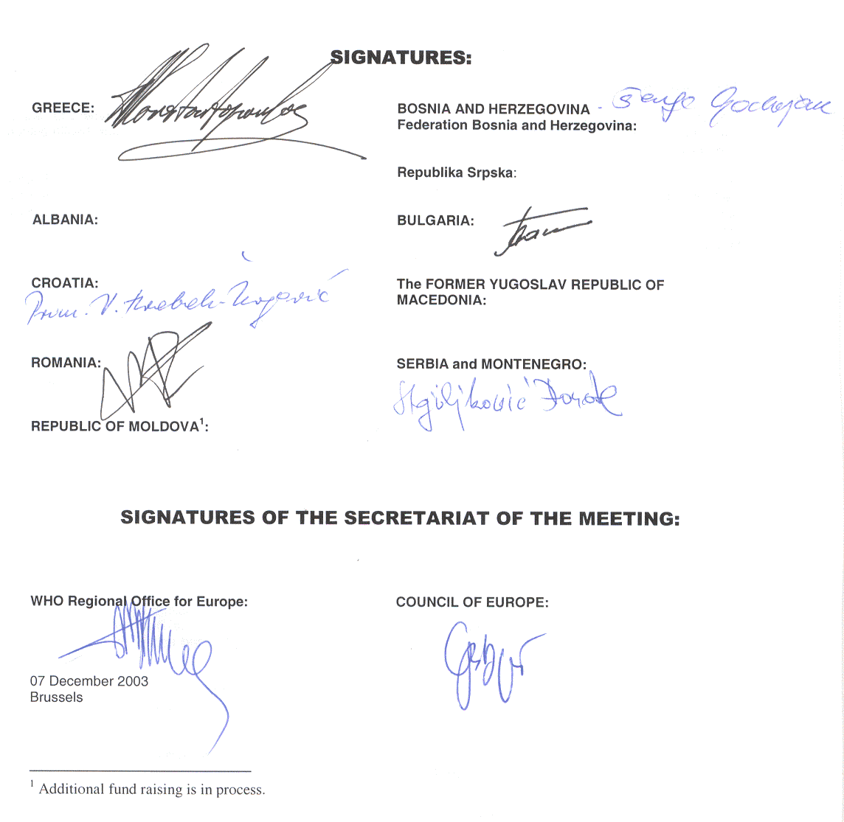

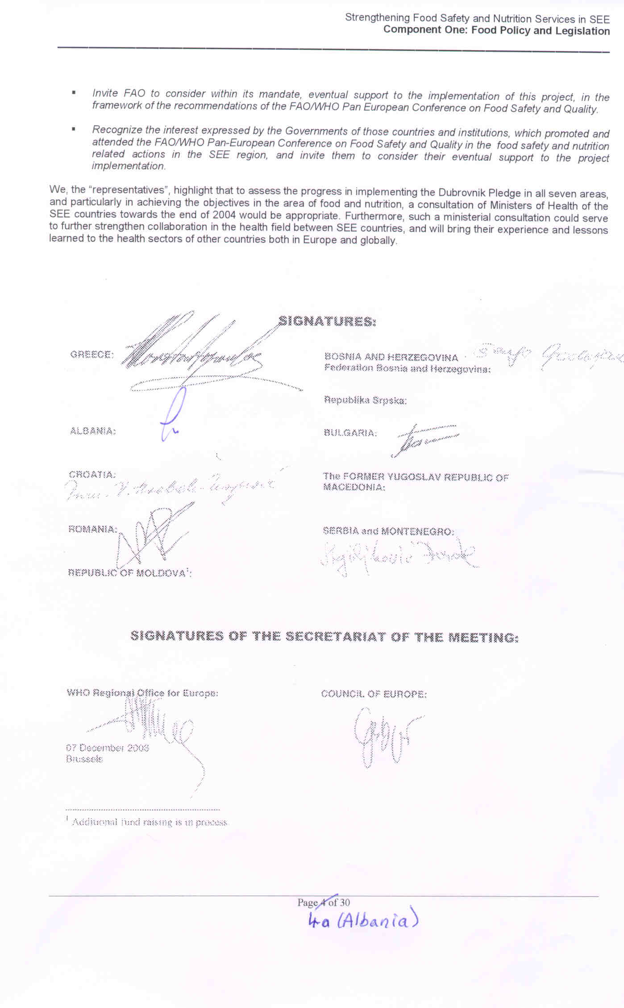

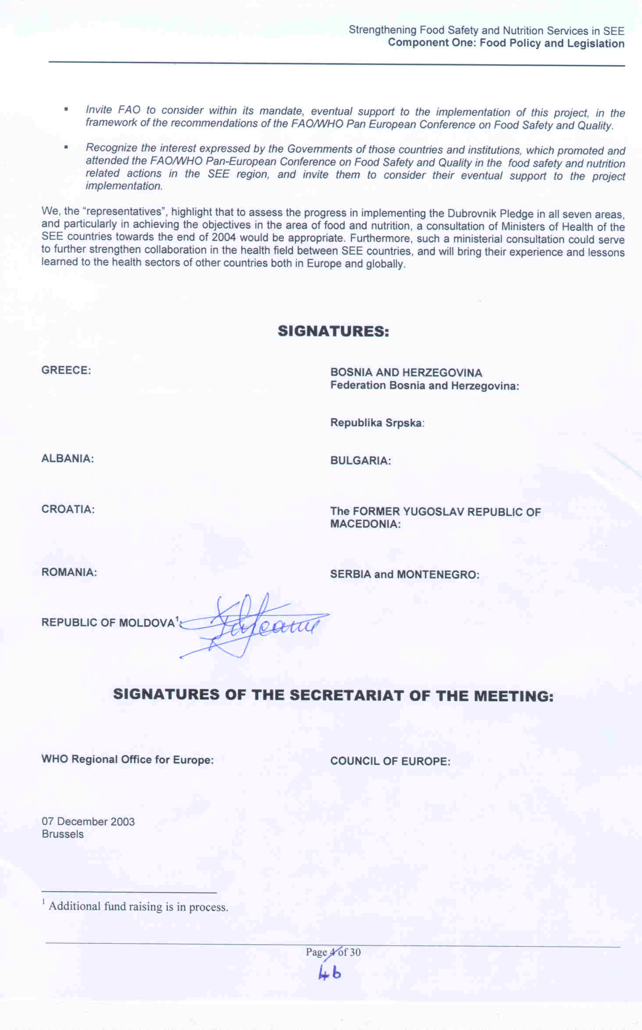

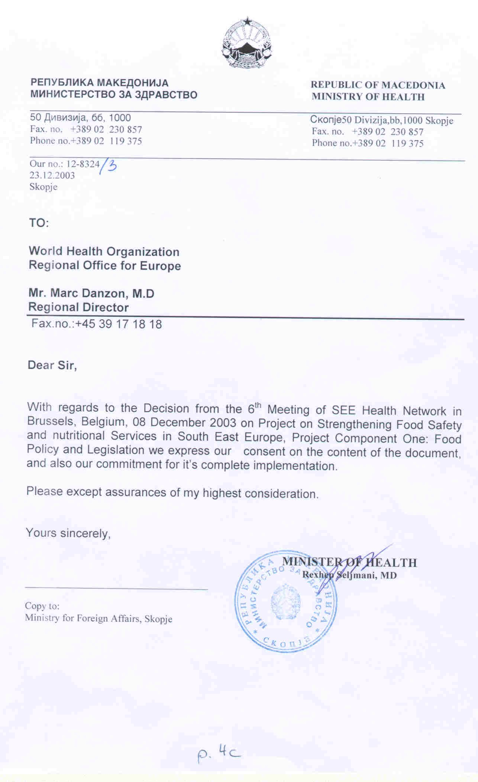

Annex 1

Strengthening Food Safety & Nutrition Services
in South East Europe:
Albania, Bosnia & Hercegovina, Bulgaria, Croatia, Moldova, Romania, Serbia and Montenegro and the Former Yugoslav Republic of Macedonia

Project Component One:
Food Policy and Legislation

Programme  Framework | Food and Nutrition Policy and Action Plans  Food Legislation and Services
Background and justification  Objective:  Project purpose:  Project Component One description:  Project Component two: Description  (upon availability of funds) | The surveillance and control of food borne and diet related diseases is a state responsibility in SEE countries and was well functioning for decades, but since these countries are in transition to market economy this system has to be adapted to the modern preventative approach concept . The SEE countries have enormous food trade potential and, also, they have potential for further development of their agricultural sectors.  In order to access EU and integrate into the common market it is necessary for these countries to harmonize all legislation and procedures in food safety according to Acquis communautaire and Codex Alimentarius standards.  In order to acquire high level of safety of food and protection of health all necessary instruments like legislation and control services have to be revised, updated and food control strategies have to be clearly identified.  Also, strengthening of the nutrition advisory services and integration of the nutritional strategy in the overall health policy in SEE countries would reduce burden of nutrition related diseases and thus promote health.  The overall aim is to decrease the number of the food-borne and diet related diseases through control and prevention. The specific objective of the project is to improve the speed and quality of detection monitoring, reporting and response to food contamination in SEE countries.  The project purpose is to strengthen the institutional capacity of the public and private components of the health system to achieve the objectives stated at central, regional and local levels with an inter-country and intersectoral approach.  Regional coordination infrastructure will be established through the creation and operation of a regional network for food safety and nutrition. This network will contribute to following international recommendations, including EU directives, norms, guidelines and methods of data reporting and surveillance.  Policy of legislation development and harmonization among SEE countries should be based on standards of the WHO FAO Codex Alimenterius Commission and the EU for food safety and prevention of food borne diseases.  Institutions in charge of food control and nutrition advisory services will be reformed organisationally and staff trained in new working procedures, including EU directives, EU Dietary Guidelines and EU Recommended Nutrient Intakes and Codex Alimentarius standards.  Laboratories will be equipped to address traditional and emerging food and diet related diseases and facilitate trade.  A number of professionals in central, regional and local institutions will be trained in new procedures.
Component one:  Steps:  Outputs:  Activities:  a) At regional level:  b) At national level: | - Government commitment  - Organisational framework  - Implementation  - Food legislation analysis and revision  - Food and Nutrition Policy and Action Plans  - Forum on Food Safety Agencies  - Sub-regional Network on Food Safety  - Capacity building, planning and management of new  investment project proposals  4. Evaluation and fund raising  - Food and Nutrition Action Plans analysis  - Draft Food Safety Strategies  - Drafts of Food Laws or revisions of existing food laws  - Concept and institutional framework for modern food safety control  - Drafts of new projects in Nutrition  - Regional Food Safety network operational  - Enhanced capacities for Food Safety (trained officials, institutions, experts  - Establishment of the project organisational and managerial set-up  - Sub-regional network on Food safety  - Database and library of all relevant international and national documents in food safety  - Workshop on Food and Nutrition Policies and Action Plans (Brijuni 2002)  - Workshop on Nutrition Food Safety policies and legislation (Belgrade 2002)  - Pan-European conference on Nutrition with meeting of SEE representatives - Draft of the new project proposal in nutrition, (Athens 2003)  - Workshop and training on food legislation, (Belgrade 2003)  - International fora for capacity building: Food Safety Agencies  - Capacity building for project planning and management  - Process and criteria for reporting, monitoring and evaluation  - Drafting of Food and Nutrition Action Plans  - Establishment of inter-ministerial body (IMB), Task Force and scientific advisory committees, to supervise the implementation of the project. This IMB could be a base for development of the future national food safety agencies and could be related with National Codex Committees.  - Designing of Food Safety Strategies and National Action plans for their implementation  - Drafting or revision of food laws  - Updating or plan for updating of secondary legislation  - Development of Codes of Practices on enforcement of legislation  - Creation of portfolio of investment project proposals- assessment of needs, creation of projects and Terms of References, additional fund rising  - Specific national activities∗ in line with the requests of acquis communautaire will focus primarily on:  ALB: Revision of the Food Law and development of codes of practice/guidelines on enforcement of legislation  BIH: Development of Food Law and secondary legislation, development of Food Safety Strategy with Action Plans  BUL: Revision of the Food Law, reform of the inspection services for HACCP audits, development of Codes of Practice (Guidelines) on enforcement of legislation,  CRO: Revision of the draft and endorsement of the Food Law, development of Food Safety Strategy, secondary legislation, Codes of Practices, creation of inter-ministrial co-ordination bodies-Food Safety Authority,  FYM: Revision of Food Law Development of Codes of Practice (Guidelines) on enforcement of legislation, creation of the Food Control Strategy  MDA: Development of Food Law (Secondary Legislation); Food Safety Strategy.  ROM: Development of Codes of Practice (Guidelines) on enforcement of legislation  Serbia & Montenegro: Development of a Food Safety Strategy, development of Food Law, revision of the secondary legislation, Codes of Practices, reform of inspection services, Food Safety Agency
Countries: | Albania, Bulgaria, Bosnia and Herzegovina, Croatia, Republic of Moldova, Romania, Serbia and Montenegro, and the Former Yugoslav Republic of Macedonia
Donor Countries: | Greece  Italy
Neighbor Countries: | Hungary  Slovenia
Potential External Partners: | Council of Europe  Council of Europe Development Bank  EU countries and non/EU countries: Sweden, Ireland, United Kingdom  EC/SANCO; Food and Veterinary Office, Dublin and Food Safety Production and Distribution Chain, Brussels  European Food Safety Authority  European Reconstruction Agency  FAO
WHO :  Responsible programmes  WHO offices | WHO/ Food Safety  WHO/ Nutrition & Food Security  WHO Country Office in the participating SEE countries

Annex 2
Logical Framework (Matrix)
For the Implementation of the Component One of the SEE Project Food Legislation
November 2002 – July 2004

Steps | Outputs | Activities | Indicators  of verifica  tion | Means of  Verification | Responsible  Organi  zations | Time  frame | Critical  assumptions
Inception and organizational set-up (at both regional and country levels)

1.  Govern  ment  Commit  ment | 1.1  Approval  of final project | 1.1.1 Revision and finalization of project  1.1.2 Approval of final draft and annexes by Government representatives  1.1.3 Endorsement of the decision by the Governments  1.1.4 Presentation of the project to donors | Finalized project  Attaining and keeping the SEE Governments commitment | Decision of Sarajevo meeting  Letters from Ministries  Contractual agreements | MoH of SEE  WHO  COE  Donor country | 6 months for activities 1-3  20 months for activity 4 | Disagreement between SEE can delay project start-off
1.  Govern  ment  Commit  ment | 1.2  Steering Committee & Executive Committee | 1.2.1 Nomination of country representatives  1.2.2 SC meetings on progress  1.2.3 Nomination of members to the EC | Intercountry composition of SC member | Governments’  decision  WHO decision  CoE decision | MoH of SEE  WHO  Donors  CoE  Project SC | 2 months  6-7 months | Assumes political will and agreement between lead Ministeries. Failure to agree could cause major delay or failure to establish IMC (Health and Agriculture Ministeries not coordinated in most countries).

Steps | Outputs | Activities | Indicators  of verifica  tion | Means of  Verification | Responsible  Organi  zations | Time  frame | Critical  assumptions
Inception and organizational set-up (at both regional and country levels)

1.  Government  Commitment | 1.3  Inter- ministerial Bodies at country level | 1.3.1 Nomination of a country project coordinator  1.3.2. Establishment of the Interministerial Body (IMB) and coordinator  1.3.2 Approval of Terms of Reference for IMB | Interministerial composition of the IMB members | Government decision | MOH of SEE | 7-8 months
2. Organisa-  tional Frame  work | 2.1 Implementation infrastructure | 2.1.1 Approval of Terms of Reference for RPM and CPMs  2.1.2 Selection and recruitment of Regional Project Manager  2.1.3 Selection and recruitment of CPMs in each country  2.1.4 Establishment of offices  2.1.5 Equipment  2.1.6 Selection of international  consultants on food legislation (both from the region and from EU countries) | Qualifications, positions and institutional affiliations of persons involved  Consultants selected | Project organization plan  ToRs  RPM  CPMs  List of national teams and advisory bodies  List of consultants | Project EC  MOH of SEE  WHO | 6-7 months | Lack of funds or delay of arrival of funds from donor countries to recruit an international project coordinator and consultants
2. Organisa-  tional Frame  work | 2.2  Work plan and time Table | 2.2.1 Preparation of detailed work plan and timetable for project coordination and implementation | Work plan and timetable developed | Coordination and implementation  plan  Timetable for implementation | RPM  CPMs  MoH of SEE | 7-8 months

Steps | Outputs | Activities | Indicators  of verifica  tion | Means of  verification | Responsible  Organi  zations | Time  frame | Critical  assumptions

3. IMPLEMENTATION / COMPONENT ONE

A. AT REGIONAL LEVEL:

3. Implementation | 3. A.1  Food and Nutrition Policies and Action Plans | 3.A.1.1 Provision of international guidance on the  process and content of NFNAPs and policies  3.A.1.2 Continuous assistance and review of SEE  countries’ NFNAPc  3.A.1.3 1st Technical Workshop on FNAPs,  cardiovascular diseases and nutrition in the  SEE region, Brijuni, Croatia, September 2002  3.A.1.4 2nd Technical Workshop on FNAPs, Belgrade,  November 2002  3.A.1.5 Pan-European Conference on Nutrition with a  satellite meeting of SEE on a new draft project  proposal on nutrition, Athens, February 2002 | International guidance collected and provided | Guidance | WHO  FAO  RPD | Month 5th and beyond
3. Implementation | 3. A.1  Food and Nutrition Policies and Action Plans |  | Assistance, external review and coaching provided |  |  | Continuous
3. Implementation | 3. A.1  Food and Nutrition Policies and Action Plans |  |  |  |  | Month 1
3. Implementation | 3. A.1  Food and Nutrition Policies and Action Plans |  |  |  |  | Month 3
3. Implementation | 3. A.1  Food and Nutrition Policies and Action Plans |  |  |  |  | Month 6
3.  Implementation | 3.A.2  Food legislation and systems analysis and revision | 3.A.2.1 Elaboration and distribution of  questionnaire on Food Legislation  3.A.2.2 Provision of information on the existing food legislative framework in the SEE  3.A.2..3 1st Technical SEE Workshop on Nutrition and Food Safety Legislation: Presentation and discussion of the actual legislative situation in the SEE countries  3.A.2.4 Preparation of detailed Country Reports on the current legislative framework on Food Safety (incl. gathering intersectorial information, analyzing the situation, proposed updates and reforms) | Questionnaire on food legislation distributed and completed  Recommendations from the countries  Presentation of the information on the food legislative framework | Questionnaire on food legislation  Responses of the questionnaire  Country reports completed  List of necessary legal updates and reforms presented | WHO  National Project Coordinators in cooperation with national experts from the Ministries of Health, Agriculture, Trade etc. and other stakeholders | 5 months  7-8 months  3 months  10-12 months | Lack of national support or/and coordination between responsible ministries and stakeholders

Steps | Outputs | Activities | Indicators  of verifica  tion | Means of  verification | Responsible  Organi  zations | Time  frame | Critical  assumptions

IMPLEMENTATION / COMPONENT ONE

A. AT REGIONAL LEVEL:
 | 3.A.3  Food legislation revision | 3.A.3.1 2nd Regional Workshop on Food Policy and Legislation in the SEE;  - Provision of the basic principles for the update of the National Food Legislation (primary General Food Law and secondary regulations),  - Introduction to the EU legislative framework and to the Codex Alimentarius Standards  - Presentation necessary reforms on food legislation in the SEE countries. | Country Project coordinators trained to update of the National Food Legislation | Publication of the report of the workshop including the presentations of the countries and recommendations to governements | International project coordinator and consultants  National Project coordinators | Month 9 | Lack of funds to  hire an international project coordinator and external consultants  Lack of National support
 | 3.A.4  Food Control Systems | 3.A.4.1 Organizing a Regional Forum to discuss development of National Food Safety Strategies, including the basis for establishment of national Food Safety Agencies in the light of EU developments | Exchanged experiences and models | Report and recommendations | WHO  FAO  EC  CoE  MOH of SEE  RPM | Month 18
 | 3.A.4  Food Control Systems | 3.A.1.2 Regional training on investment projects planning and management |  |  |  | Month 16
 | 3.A.5  SEE Regional Food Safety Network | 3.A.5.1 Nomination of responsible national institutions |  |  | SEE MOH  National Institutions  RPM  CPMs  WHO  FAO | Month 12
 | 3.A.5  SEE Regional Food Safety Network | 3.A.5.2 Establishing of communication lines through e-mail as a start |  |  | SEE MOH  National Institutions  RPM  CPMs  WHO  FAO | Month 12-13
 | 3.A.5  SEE Regional Food Safety Network | 3.A.5.3 Website |  |  | SEE MOH  National Institutions  RPM  CPMs  WHO  FAO | Month 13-14
 | 3.A.5  SEE Regional Food Safety Network | 3.A.5.4 Database and library |  |  | SEE MOH  National Institutions  RPM  CPMs  WHO  FAO | Month 13-20

Steps | Outputs | Activities | Indicators  of verifica  tion | Means of  verification | Responsible  Organi  zations | Time  frame | Critical  assumptions
3. B. AT NATIONAL LEVEL

3. B Implementation | 3.B.1  National Food and Nutrition Action Plan | 3.B.1.1 Establishing national Task Force  3.B.1.2 First draft NFNAP  3.B.1.3 International review  3.B.1.4 Second draft NFNAP  3.B.1.5 Governmental and public consultations  3.B.1.6 Finalization of NFNAPs  3.B.1.7 Adoption |  |  |  | Month 9 Month 20
3. B Implementation | 3.B.2  Food Legislation update | 3.B.2.1 Drafting and/or revision of the primary  Food Law  3.B.2.2 Formulating of National Food Safety Strategy and framework for the development of secondary regulations  3.B.2.3 Development of codes of practice on the enforcement of the food law  3.B.2.4 Particular technical support tailored to countries needs aiming at the reorganization and strengthening of the food control systems for the implementation of food legislation, Creation of inter-ministerial co-ordination bodies/agencies, etc) | Preparation of the draft of the General Primary Food Laws | Inter-ministerial commission Presents the final draft of the General Food Law | Inter-ministerial commission and National Project coordinators  International project coordinator  External consultants | Month 9  Months 20 | Lack of funds for international project coordinator and external consultants  Lack of commitment at national level  Difficulty in recruiting appropriate consultants within budget
3. B Implementation | 3.B.3 Food  Control System Concept | 3.B.3.1 Situation Analysis |  |  |  | 10-11months
3. B Implementation | 3.B.3 Food  Control System Concept | 3.B.3.2 Analysis of international recommendations and models, particularly in the light of EU developments |  |  |  | 11-12 months
3. B Implementation | 3.B.3 Food  Control System Concept | 3.B.3.3 First draft concept on a national food control system |  |  |  | 14-15 months
3. B Implementation | 3.B.3 Food  Control System Concept | 3.B.3.4 Public discussion |  |  |  | 16-18 months
3. B Implementation | 3.B.3 Food  Control System Concept | 3.B.3.5 Investment project proposals |  |  |  | 16-18 months

Steps | Outputs | Activities | Indicators  of verifica  tion | Means of  verification | Responsible  Organi  zations | Time  frame | Critical  assumptions
3. B Implementation | 3.B.4  Capacity building and coaching for implementation | 3.B.4.1 National workshops tailored to the needs of the individual countries  3.B.4.2 Provision of international expert consultations upon request | Recommendations from the countries | Report form the meeting with recommendations for a code of practice | WHO  International project coordinator  External consultants  National Project coordinators | Months 11 and beyond | Lack of funds for international project coordinator and external consultants
C. EVALUATION ( At both regional and national levels)
4. Evaluation and  Fund raising for follow up | 4.1  Evaluation of the Implementation | 4.1.1 Preparation of system and criteria for project reporting, monitoring and evaluation  4.1.2 Progress and completion report  4.1.3 Evaluation of the update of the primary food laws and of the national situation for development of secondary specific food regulations  4.1.4 Additional fundraising for capacity building to implement food legislation (surveillance and monitoring, training for inspectors and food producers, training for professionals from laboratories for food control, analytical quality assurance programmes, etc.) | Reports from the countries  Conclusions  Recommendations | National and sub-regional evaluation reports  Fund raising Proposals finalized | CPMs  RPM  External consultants  WHO, CoE  MoH of SEE  Donors | Months 9-12  Mid-term Months 19  Last 3 months | Lack of funds for international project coordinator and external consultants.  Lack of support or human resources at national level.  Lack of support at national level. Lack of support from donors

Annex 3
Project Implementation Plan (PIP)
For the Implementation of the Component One of the SEE Project Food Legislation
September 2002 – June 2004

Steps | Outputs | Activities | 1 | 2 | 3 | 4 | 5 | 6 | 7 | 8 | 9 | 10 | 11 | 12 | 13 | 14 | 15 | 16 | 17 | 18 | 19 | 20
Inception and organizational set-up (at both regional and country levels)

1.  Govern  ment  Commit  ment | 1.1  Approval  of final project | 1.1.1. Revision and finalization of project
1.  Govern  ment  Commit  ment | 1.1  Approval  of final project | 1.1.2 Approval of final draft and annexes by Government r representatives
1.  Govern  ment  Commit  ment | 1.1  Approval  of final project | 1.1.3 Endorsement of the decision by the Governments
1.  Govern  ment  Commit  ment | 1.1  Approval  of final project | 1.1.4 Presentation of the project to donors
1.  Govern  ment  Commit  ment | 1.2  Steering Committee &  Executive Committee | 1.2.1 Nomination of country representatives
1.  Govern  ment  Commit  ment | 1.2  Steering Committee &  Executive Committee | 1.2.2 SC meetings on progress
1.  Govern  ment  Commit  ment | 1.2  Steering Committee &  Executive Committee | 1.2.3 Nomination of members to the EC
1.  Govern  ment  Commit  ment | 1.3 Interministerial Bodies  At country level | 1.3.1 Nomination of a country project coordinator
1.  Govern  ment  Commit  ment | 1.3 Interministerial Bodies  At country level | 1.3.2 Establishment of the Interministerial Commission (IMC) and coordinator
1.  Govern  ment  Commit  ment | 1.3 Interministerial Bodies  At country level | 1.3.3 Approval of Terms of Reference for ICM

Steps | Outputs | Activities | 1 | 2 | 3 | 4 | 5 | 6 | 7 | 8 | 9 | 10 | 11 | 12 | 13 | 14 | 15 | 16 | 17 | 18 | 19 | 20
Inception and organizational set-up (at both regional and country levels)

2. Organisa-  tional Frame  work | 2.1 Implementation infrastructure | 2.1.1 Approval of Terms of Reference for RPM and CPMs
2. Organisa-  tional Frame  work | 2.1 Implementation infrastructure | 2.1.2 Selection and recruitment of Regional Project Manager
2. Organisa-  tional Frame  work | 2.1 Implementation infrastructure | 2.1.3 Selection and recruitment of CPMs in each country
2. Organisa-  tional Frame  work | 2.1 Implementation infrastructure | 2.1.4 Establishment of offices
2. Organisa-  tional Frame  work | 2.1 Implementation infrastructure | 2.1.5 Equipment
2. Organisa-  tional Frame  work | 2.1 Implementation infrastructure | 2.1.6 Selection of international consultants on food legislation (both from the region and from EU countries)
2. Organisa-  tional Frame  work | 2.2  Work plan and time Table | - Preparation of detailed work plan and timetable for project coordination and implementation

Steps | Outputs | Activities | 1 | 2 | 3 | 4 | 5 | 6 | 7 | 8 | 9 | 10 | 11 | 12 | 13 | 14 | 15 | 16 | 17 | 18 | 19 | 20
IMPLEMENTATION / COMPONENT ONE

A. AT REGIONAL LEVEL:
3.  Implementation | 3.A.1  Food and Nutrition Policies and Actions Plans | 3.A.1.1 Provision of international guidance on the process and content of NFNAPS and policies
3.  Implementation | 3.A.1  Food and Nutrition Policies and Actions Plans | 3.A.1.2 Continuous assistance and review of SEE countries’ NFNAPs
3.  Implementation | 3.A.1  Food and Nutrition Policies and Actions Plans | 3.A.1.3 1st Technical workshop on FNAPs, cardiovascular diseases and nutrition in the SEE Region, Brijuni, Croatia, September 2002
3.  Implementation | 3.A.1  Food and Nutrition Policies and Actions Plans | 3.A.1.4 2nd Technical workshop FNAPs, Belgrade, November 2002
3.  Implementation | 3.A.1  Food and Nutrition Policies and Actions Plans | 3.A.1.5 Pan-European Conference on Nutrition with a satellite meeting of SEE on a new draft project proposal on nutrition, Athens, February 2002
3.  Implementation | 3.A.2  Food Legislation and systems analysis and revision | 3.A.2.1 Elaboration and distribution of  questionnaire on Food Legislation

Steps | Outputs | Activities | 1 | 2 | 3 | 4 | 5 | 6 | 7 | 8 | 9 | 10 | 11 | 12 | 13 | 14 | 15 | 16 | 17 | 18 | 19 | 20
IMPLEMENTATION / COMPONENT ONE
A. AT REGIONAL LEVEL:
 |  | 3.A.2.2 Provision of information on the existing food legislative framework in the SEE
 |  | 3.A.2.3 1st Technical SEE workshop on Nutrition and Food Safety Legislation: Presentation and discussion of the actual legislative situation in the SEE countries
 | 3.A.2  Food Legislation and systems analysis and revision | 3.A.2.4 Preparation of detailed Country Reports on the current legislative framework on Food Safety (incl. Gathering intersectorial information, analyzing the situation, proposed updates and reforms)
 |  | 3.A.2.5 2nd Regional workshop on Food Policy and Legislation in the SEE countries
 | 3.A.3  Food Control Systems | 3.A.3.1 Organizing a Regional Forum to discuss development of National Food Safety Strategies, including the basis for establishment of national Food Safety Agencies in the light of EU developments
 | 3.A.3  Food Control Systems | 3.A.3.2 Regional training on investment projects planning and management

Steps | Outputs | Activities | 1 | 2 | 3 | 4 | 5 | 6 | 7 | 8 | 9 | 10 | 11 | 12 | 13 | 14 | 15 | 16 | 17 | 18 | 19 | 20
IMPLEMENTATI0N / COMPONENT ONE

 | 3.A.4  SEE Regional Food Safety Network | 3.A.4.1 Nomination of responsible national institutions
 | 3.A.4  SEE Regional Food Safety Network | 3.A.4.2 Establishment of communication lines through email as a start
 | 3.A.4  SEE Regional Food Safety Network | 3.A.4.3 Website
B. AT NATIONAL LEVEL:
B. Implementation | B.1  National Food and Nutrition Action Plan | B.1.1 Establishing National Task Force
B. Implementation | B.1  National Food and Nutrition Action Plan | B.1.2 First Draft NFNAP
B. Implementation | B.1  National Food and Nutrition Action Plan | B.1.3 International Review
B. Implementation | B.1  National Food and Nutrition Action Plan | B.1.4 Second draft NFNAP
B. Implementation | B.1  National Food and Nutrition Action Plan | B.1.5 Governmental and public consultations
B. Implementation | B.1  National Food and Nutrition Action Plan | B.1.6 Finalization of NFNAPs
B. Implementation | B.1  National Food and Nutrition Action Plan | B.1.7 Adoption
 | B.2  Food Legislation and update | B.2.1 Drafting and/or revision of the primary Food Law
 | B.2  Food Legislation and update | B.2.2 Formulation of National Food Safety Strategy and framework for the development of secondary regulations

Steps | Outputs | Activities | 1 | 2 | 3 | 4 | 5 | 6 | 7 | 8 | 9 | 10 | 11 | 12 | 13 | 14 | 15 | 16 | 17 | 18 | 19 | 20
IMPLEMENTATI0N / COMPONENT ONE

B. AT NATIONAL LEVEL:
Implementa  tion | B.2  Food Legislation and update | B.2.3 Development of codes of practice on the enforcement of the food law
Implementa  tion | B.2  Food Legislation and update | B.2.4 Particular needs from the countries
Implementa  tion | B.3  Food Control System Concept | B.3.1 Situation Analysis
Implementa  tion | B.3  Food Control System Concept | B.3.2 Analysis of international recommendations and models, particularly in the light of EU developments
Implementa  tion | B.3  Food Control System Concept | B.3.3 First draft concept on national food control system
Implementa  tion | B.3  Food Control System Concept | B.3.4 Public discussion
Implementa  tion | B.3  Food Control System Concept | B.3.5 Investment project proposals
 | B.4  Capacity building and coaching for implementation | 3.B.4.1 National workshops tailored to the needs of the individual countries
 | B.4  Capacity building and coaching for implementation | 3.B.4.2 Provision of international expert consultations upon request

Annex 4

Organizational Set-up

for the Food Safety and Nutrition Project

The project organizational set-up comprises of two levels:
At the political level - a Steering Committee (SC)
At the management level - an Executive Committee (EC)
- a Regional Project Office (RPO) with a Regional Project Manager (RPM)
- Country Project Offices (CPOs) with Country Project Managers (CMPs)

Steering Committee (SC)

The key responsibility of the SC is to monitor, supervise and evaluate project implementation. This will be done by approving project reports, i.e. the progress reports and the final report.

- The SC is composed of:
- Representatives from the eight beneficiary countries
- Representative from the WHO Regional Office for Europe
- Representative from the Council of Europe
- Representatives from the donor countries

- The members of the SC are appointed by the Ministers of Health of the participating countries, by the WHO Regional Director and by the CoE Director General for Social Cohesion and Health

- Donor countries without a substantial contribution to the funding of the project can appoint co-opted members to the SC (without vote), provided that the interested countries cover the cost of their participation

- The votes of WHO, CoE and the donor countries constitute the majority in the SC. In particular, their votes are distributed as follows:
- WHO – 1 vote
- CoE – 1 vote
- Italy – 1 vote
- Greece – the rest of the votes

5. New donor countries will appoint members to the SC at the expense of members appointed by Greece, but in the final constitution of the SC Greece will have a minimum of two votes, as the main partner-donor.

6. Proposed major changes related to the project sub-components, outputs and activities put forward by an individual country, can be submitted for approval to the SC through the management structure of the project, which also submits its opinion and advice to the SC for its final decision.

7. The SC amongst its other duties plays the key role of the project promoter and advocate, as well as the role of mobilizer of partners and resources, directed towards the sustainability and successful implementation of the project. In the above context, the SC can propose the transformation of the project, or any of its sub-components, to a long term programme, should additional funds become available through the aforementioned activities of the SC.

- The SC appoints the EC.

- The SC will elect amongst its members, a Chairman and a Rapporteur and will approve the terms of reference for the posts of the RPM and the CPMs.

Executive Committee (EC)

The EC is the highest-level management body of the project. It, therefore, coordinates and oversees all the project objectives, outputs and activities and supervises the Regional Project Manager, who reports to the EC regularly every two months and in addition whenever it is deemed appropriate.

- The EC is composed of:
- One member from Serbia and Montenegro (project lead country)
- One member from WHO (global advisory organization for health)
- One member from Greece (main partner-donor country)

- The EC is appointed by the SC after nominations by the Ministry of Foreign Affairs of Serbia and Montenegro, the WHO Regional Director for Europe and the Minister of Health and Welfare of Greece

- Once the above nominations have been accepted by the SC, membership of the EC can only change either through resignation of a member or through a decision by the SC

- The EC has the right to re-allocate funds, subject to approval by the members of the donor countries, WHO and CoE.

- The EC has the right to approve extensions from the agreed time frame of implementation, should the situation makes it necessary.

- The EC has the responsibility for resolving crises and disagreements, which occur between individual countries, CPMs, RPM and constitute major deviations from the agreed objectives, outputs and activities of the project.

- The EC introduces for approval to the SC the closure of the budget of the previous year and proposes the budget for the following year

- The proposals of the CPMs and of the RPM with regard to the qualifications and recruitment of the full and part-time salaried staff for the project, has to be approved by the EC prior to their appointment.

- The EC selects the RPM amongst candidates from Serbia and Montenegro (project lead country), through an open and transparent process, in line with the terms of reference approved by the SC in its inaugural meeting, and submits its choice to the government of Serbia and Montenegro for appointment of the successful candidate.

- The EC selects the CPMs from a list of three candidates from each country, proposed by the Ministry of Health, in line with the terms of reference approved by the SC and submits its choice to the respective minister for the appointment of the successful candidate. Interviews of the candidates could be carried out by the EC, should it deem it appropriate.

- The members of the EC decide amongst themselves the chairmanship of the committee, on a rotational basis.
- The EC meets regularly every four months and also at whatever time it deems necessary.

Regional Project Manager (RPM)

To secure successful implementation of the project, the RPM has the following duties and responsibilities:

- Coordinates the work of the CPMs

- Responsible for the day-to-day activities of the regional office

- Responsible for the organization and management of the intercountry activities

- Responsible for the monitoring of the progress of project implementation in all participating countries

- Reports every two months to the EC on the progress of project implementation, including problems faced and proposals for solutions, which is based on the country reports

- Reports and proposes subjects for discussion and decision to the EC

- Proposes to the EC re-allocations and changes of outputs and activities, in consultation with the CPMs

- Acts as Secretariat to the EC and the SC

Country Project Manager (CPM):

The CPM is responsible for the successful implementation of the project outputs and activities at the national level. The detailed description of work to be performed by the CPM is defined in the project document. In this context, the CPM has the following main responsibilities, duties and tasks:

- Launches the project in the country

- Prepares the specific sub-objectives, activities, tasks, workplan, timetable and budget (LFA) for the “inception report”

- Prepares the implementation framework for the recipient country

- Organizes the implementation system in the country

- Coordinates the country activities for the project;

- Proposes local experts for hiring under the project as appropriate;

- Liases constantly with the RPM and the national project managers in each of the other recipient countries;

- Mobilizes other relevant governmental institutions, sectors, local authorities and external partners

- Monitors the implementation of activities agreed;

- Reports to the RPM and the EC in the format required

- Builds up an accounting and invoicing system according to agreed requirements

- Prepares the financial statements and reports to the donors as agreed and submits them through the RPM

- Keeps records and files

Annex 5

Budget Breakdown per SEE Country
For the Implementation of the Component One of the Project on Food Legislation
September 2002 – June 2004

Steps | Outputs |  | Activities |  | Budget Break down by SEE Country in EUROs
Steps |  |  |  |  | Total |  | ALB |  | BIH |  | BUL |  | CRO |  | MDA |  | ROM |  | S&M |  | FYM
Inception and organizational set-up (at both regional and country levels)
1.  Govern  ment  Commit  ment |  | 1.1  Approval  of final project |  | 1.1.1 Revision and finalization of project |  | 0
 |  |  |  | 1.1.2 Approval of final draft and annexes by Government representatives |  | 0
 |  |  |  | 1.1.3 Endorsement of the decision by the Governments |  | 0
 |  |  |  | 1.1.4 Presentation of the project to donors |  | 0
 |  | 1.2  Steering Committee &  Executive Committee |  | 1.2.1 Nomination of country representatives |  | 0
 |  |  |  | 1.2.2 SC meetings on progress |  | 0
 |  |  |  | 1.2.3 Nomination of members to the EC |  | 0
 |  | 1.3  Interministerial Bodies  At country level |  | 1.3.2 Establishment of the Interministerial Body (IMB) and coordinator |  | 0
 |  |  |  | 1.3.3 Approval of Terms of Reference for IMB |  | 0
2.  Organisa-  tional Frame  work |  | 2.1  Implementation infrastructure |  | 2.1.1 Approval of Terms of Reference for RPM and CPMs |  | 0
 |  |  |  | 2.1.2 Selection and recruitment of Regional Project Manager |  | 5 715 |  | 715 |  | 715 |  | 715 |  | 715¹ |  | 715 |  | 715 |  | 715 |  | 715
 |  |  |  | 2.1.3 Running costs |  | 5 715 |  | 715 |  | 715 |  | 715 |  | 715¹ |  | 715 |  | 715 |  | 715 |  | 715

Steps | Outputs | Activities | Budget Break down by SEE Country in EUROs
Steps | Outputs | Activities | Total | ALB | BIH | BUL | CRO | MDA | ROM | S&M | FYM
Inception and organizational set-up (at both regional and country levels)
2. Organisational Framework | 2.1 Implementation infrastructure | 2.1.4 Selection and recruitment of CPMs in each country | 0
2. Organisational Framework | 2.1 Implementation infrastructure | 2.1.5 Establishment of country offices | 0
2. Organisational Framework | 2.1 Implementation infrastructure | 2.1.6 Running costs of country offices | 8 000 | 1 000 | 1 000 | 1 000 | 1 000 | 1000¹ | 1 000 | 1 000 | 1 000
2. Organisational Framework | 2.1 Implementation infrastructure | 2.1.7 Equipment of country offices | 24 000 | 3 000 | 3 000 | 3 000 | 3 000 | 3 000¹ | 3 000 | 3 000 | 3 000
2. Organisational Framework | 2.1 Implementation infrastructure | 2.1.8 Selection of international consultants on food legislation (both from the region and from EU countries)
2. Organisational Framework | 2.2  Work plan and time Table | 2.2.1 Preparation of detailed work plan and timetable for project coordination and implementation

Steps | Outputs |  | Activities |  | Budget breakdown by SEE Country in EUROs
Steps |  |  |  |  | Total |  | ALB |  | BIH |  | BIL |  | CRO |  | MDA¹ | ROM |  |  | S&M |  | FYM
IMPLEMENTATION / COMPONENT ONE
A. AT REGIONAL LEVEL:
3.  Implementation |  | 3.1  Food and Nutrition Policies and Action Plans |  | 3.1.1 Provision of international guidance on the process and content of NFNAPs and policies |  | --
 |  |  |  | 3.1.2 Continuous assistance and review of SEE countries’ NFNAPc |  | --
 |  |  |  | 3.1.3 1st Technical Workshop on FNAPs, cardiovascular diseases and nutrition in the SEE region, Brijuni, Croatia, September 2002 |  | 13 751 |  | 1 715 |  | 1 751 |  | 1 751 |  | 1 751 | 1 750¹ |  | 1 751 | 1 751 |  | 1 751
 |  |  |  | 3.1.4 2nd Technical Workshop on FNAPs, Belgrade, November 2002 |  | 11 428 |  | 1 428 |  | 1 428 |  | 1 428 |  | 1 428 | 1 428¹ |  | 1 428 | 1 428 |  | 1 428
 |  |  |  | 3.1.5 Pan-European Conference on Nutrition with a satellite meeting of SEE on a new draft project proposal on nutrition, Athens, February 2002 |  | 13 715 |  | 1 715 |  | 1 715 |  | 1 715 |  | 1 715 | 1 715¹ |  | 1 715 | 1 715 |  | 1 715
 |  | 3.2  Food legislation and systems analysis and revision |  | 3.2.1 Elaboration and distribution of questionnaire on  Food Legislation |  | -- |  |  |  |  |  |  |  |  | --
 |  |  |  | 3.2.2 Provision of information on the existing food legislative framework in the SEE |  | -- |  |  |  |  |  |  |  |  | --
 |  |  |  | 3.2.3 1st Technical SEE Workshop on Nutrition and Food Safety Legislation: Presentation and discussion of the actual legislative situation in the SEE countries |  | 11 428 |  | 1 428 |  | 1 428 |  | 1 428 |  | 1 428 | 1 428¹ |  | 1 428 | 1 428 |  | 1 428

Steps | Outputs | Activities | Budget Break down by SEE Country in EUROs
Steps | Outputs | Activities | Total | ALB | BIH | BUL | CRO | MDA | ROM | S&M | FYM

IMPLEMENTATION / COMPONENT ONE
A. AT REGIONAL LEVEL:
 | 3.3  Food legislation and systems analysis and revision | 3.3.1 Preparation of detailed Country Reports on the current legislative framework on Food Safety (incl. gathering intersectorial information, analyzing the situation, proposed updates and reforms) | -- | -- | -- | -- | -- | -- | -- | -- | --
 | 3.4  Food legislation revision | 3..4. 2nd Regional Workshop on Food Policy and Legislation in the SEE, Belgrade, May 2003 | 57 142 | 7 142 | 7 142 | 7 142 | 7 142 | 7 142¹ | 7 142 | 7 142 | 7 142
 | 3.5  Food Control Systems | 3.5.1 Organizing a Regional Forum to discuss development of National Food Safety Strategies, including the basis for establishment of national Food Safety Agencies in the light of EU developments | 34 285 | 4 285 | 4 285 | 4 285 | 4 285 | 4 285¹ | 4 285 | 4 285 | 4 285
 | 3.5  Food Control Systems | 3.5.2 Regional training on investment projects planning and management | 28 571 | 3 571 | 3 571 | 3 571 | 3 571 | 3 571¹ | 3 571 | 3 571 | 3 571
 | 3.6  SEE Regional Food Safety Network | 3.6.1 Nomination of responsible national institutions | 0
 | 3.6  SEE Regional Food Safety Network | 3.6.2 Establishing of communication lines through e-mail as a start | 0
 | 3.6  SEE Regional Food Safety Network | 3.6.3 Website | 3 428 | 428 | 428 | 428 | 428 | 428¹ | 428 | 428 | 428
 | 3.6  SEE Regional Food Safety Network | 3.6.4 Database and library | 0

Steps | Outputs | Activities | Budget Break down by SEE Country in EUROs
Steps | Outputs | Activities | Total | ALB | BIH | BUL | CRO | MDA¹ | ROM | S&M | FYM

IMPLEMENTATION / COMPONENT ONE
B. AT NATIONAL LEVEL:
B.1 Implementation | B.1.1  National Food and Nutrition Action Plan | B.1.1.2 Establishing national Task Force | 127 428 | 15 928 | 15 928 | 15 928 | 15 928 | 15 928¹ | 15 928 | 15 928 | 15 928
B.1 Implementation | B.1.1  National Food and Nutrition Action Plan | B.1.1.3 First draft NFNAP
B.1 Implementation | B.1.1  National Food and Nutrition Action Plan | B.1.1.4 International review
B.1 Implementation | B.1.1  National Food and Nutrition Action Plan | B.1.1.5 Second draft NFNAP
B.1 Implementation | B.1.1  National Food and Nutrition Action Plan | B.1.1.6 Governmental and public consultations
B.1 Implementation | B.1.1  National Food and Nutrition Action Plan | B.1.1.7 Finalization of NFNAPs
B.1 Implementation | B.1.1  National Food and Nutrition Action Plan | B.1.1.8 Adoption
B.1 Implementation | B.1.2  Food Legislation update | B.1.2.1 Drafting and/or revision of the primary Food Law
B.1 Implementation | B.1.2  Food Legislation update | B.1.2.2 Formulating of National Food Safety Strategy and framework for the development of secondary regulations
B.1 Implementation | B.1.2  Food Legislation update | B.1.2.3 Development of codes of practice on the enforcement of the food law
B.1 Implementation | B.1.2  Food Legislation update | B1.2.4 Particular needs from the countries
B.1 Implementation | B.1.3  Food Control System Concept | B.1.3.1 Situation Analysis
B.1 Implementation | B.1.3  Food Control System Concept | B.1.3.2 Analysis of international recommendations and models, particularly in the light of EU developments

Steps | Outputs | Activities | Budget Break down by SEE Country in EUROs
Steps | Outputs | Activities | Total | ALB | BIH | BUL | CRO | MDA | ROM | S&M | FYM
IMPLEMENTATION / COMPONENT ONE
B. AT NATIONAL LEVEL*:
B.1 Implementation | B.1.4  Food Control Systems Concept | B.1.4.1 First draft concept on a national food control system
B.1 Implementation | B.1.4  Food Control Systems Concept | B.1.4.2 Public discussion
B.1 Implementation | B.1.4  Food Control Systems Concept | B.1.4.3 Investment project proposals
B.1 Implementation | B.1.5  Capacity building and coaching for implementation | B.1.5.1National workshops tailored to the needs of the individual countries
B.1 Implementation | B.1.5  Capacity building and coaching for implementation | B.1.5.2Provision of international expert consultations upon request
EVALUATION (At both regional and national levels)
C. 1  Evaluation  and Fund raising for follow up | C.1.1  Evaluation of the Implementation | C.1.1.1 Preparation of system and criteria for project reporting, monitoring and evaluation | 0
C. 1  Evaluation  and Fund raising for follow up | C.1.1  Evaluation of the Implementation | C.1.1.2 Progress and completion report | 0
C. 1  Evaluation  and Fund raising for follow up | C.1.1  Evaluation of the Implementation | C.1.1.3Evaluation of the update of the primary food laws and of the national situation for development of secondary specific food regulations | 0
C. 1  Evaluation  and Fund raising for follow up | C.1.1  Evaluation of the Implementation | C.1.1.4 Additional fund raising for capacity building to implement food legislation | 0
TOTAL FOR COMPONENT ONE, BOTH AT REGIONAL AND NATIONAL LEVELS |  |  | 34 4 570 | 43 070 | 43 070 | 43 070 | 43 070 | 43 070¹ | 43 070 | 43 070 | 43 070

 To be further specified by each individual country while preparing the country workplan to implement the project within the available funds. Tailoring the activities of the countries to their specific needs is to be made in the frame of the agreed regional outputs.
The office space, furniture, basic equipment, telephone and other communication facilities for Component One will be in kind contribution of each SEE country
Each SEE country will have the opportunity, within the limited allocation, to be provided with some equipment, based on the specific needs, to be used for the project purposes, namely good management and regional communication
The office space, furniture, basic equipment, telephone and other communication facilities for Component One will be in kind contribution of each SEE country
Each SEE country will have the opportunity, within the limited allocation, to provide some equipment based on the specific needs to be used for the project purposes, namely good management and regional communication
The functions described are applicable to a fully developed RPO. At this stage, because of lack of sufficient funds, RPM will be responsible for functions1,3,4,5,6,7 and 8.
Not fully recruited.
Fundraising for activities of MDA in progress.
The office space, furniture, basic equipment, telephone and other communication facilities for Component One will be in kind contribution of each SEE country.
Through the Greek donation.
Each SEE country will have the opportunity, within the limited allocation, to provide some equipment based on the specific needs to be used for the project purposes, namely good management and regional communication.

