Annex

Technical specification according to item 2

Background information

The Ministry of Agriculture and Forestry of Bulgaria has asked for assistance with the establishment of a “test project” by using the Austrian IACS software system developed by Austrian experts. Austria has installed a test environment which is able to run the whole software on a small dataset. This test system can be chosen to be transmitted as the Bulgarian “IACS Test System”.

Objectives

General

- The time frame is JUNE 2005 to have the system installed in the Bulgarian infrastructure.

- The Austrian test system is carried out in German language based on Austrian data. One of the Austrian experts’ objectives is to present Bulgarian data of one municipality and will be shown in Latin characters in the system.

The project will be carried out in two phases.

Phase 1:

- Copy of existing Austrian dataset of the test system where personal data have to be changed into anonymous data. This system is designed and programmed in German language and contains the complete Austrian process of direct payments administration as well as Austrian data.

- We concentrate on the following parts of the Austrian system:

  - Farmers/Farm Register
  - LPIS
  - Animals Register
  - Integration LPIS and GIS
  - Administration of registers for IACS use

Phase 2:

- Initial steps to adapt the Austrian System to the Bulgarian use to prove the concept

  - Integration in Bulgarian LAN system
  - Migrating Bulgarian data of one municipality
  - Test
  - Training
  - Evaluation
  - Documentation

Scope of work

System description

As this project is carried out on the basis of the existing Austrian IACS, this Austrian system serves as the reference for the system description. In the following the contents listed in the Objectives section will be addressed only briefly.

Farmers/Farm Register

The Register of Farms and Farmers permits the technical data management of the master data of the potential applicants. Master data are for instance names, addresses, telephone numbers, and also banking connections.

Animals Register

The average number of farmed animals and the number of farmed animals on a fixed day are registered and documented for the aid scheme.

LPIS

The LPIS data shall be provided by the Bulgarian side according to the form of the Austrian system.

Integration LPIS and GIS

The areas actually utilised for agricultural purposes are recorded in the Austrian system through IACS-GIS.

Administration of registers for IACS use

In order to support the different data contained in the registers, basic functions (re-establish, modify, historicise, etc.) are provided. Special attention shall be paid to the administration of the geo-data (area administration, excessive utilisation, list of areas per applicant, etc.)
Furthermore, the super-ordinate cross-checks of the registers have to be considered.

Technical content

4.1. Hardware

Prerequisite:
Items | ID | Qty | Price
- HP ML 110 SERVER 2 GB DDR  - ALPHA ASVDS15 RM KMAT SERVER DS 15  - ALPHA ASVDS15 RM KMAT SERVER  - L1530 15 TFT Monitor  - HP SDLT 160/320 GB | HP ML 110/4423  Alpha ASVDS15/1067  Alpha ASVDS15/1136  L1530 15 TFT 5870  L1530 15 TFT 5896  L1530 15 TFT 5905  HP SDLT 160/320/2604  HP SDLT 160/320/2387 | 1  1  1  3  2 | 3 107.00 EUR  27 322.00 EUR  35 346.00 EUR  1 785.00 EUR  8 440.00 EUR
TOTAL |  |  | 76 000.00 EUR

4.2 Standard software

Database:
ORACLE Enterprise Edition incl. Partition 1 Year License  (minimum license 25 named user) engl. | 5.100,00 EUR
ORACLE SPATIAL 1 Year License (minimum license 25 named user) engl. | 1.023,00 EUR
ORACLE IAS 1 Year License (minimum license 10 named user) engl. | 816,00 EUR
ORACLE Internet Developer Suite 1 Year License (for 4 user) | 3.772,00 EUR
Quest SQL Navigator Professional edition (for 4 user) | 5.860,00 EUR
The listed prices are estimations based on Austrian list prices.
GIS software:
IACS WebMapping engl. | 13.500,00 EUR

4.3. Implementation

Phase 1:
Preconditions:
The required HW has to be assembled together with the fully operable operating system in English. All configured servers and clients have to have reserved IP-addresses and be configured within the LAN.

Task | AMA  experts *) | AMA IT *) | AMA  GIS*)
a) Hardware setup-check including network usability |  | 2 | 1
b) Setup & configuration of Oracle-Database Environment | 1 | 4
c) Setup & configuration of Oracle-Web-Environment  (IAS, Spatial, …) |  | 7 | 2
d) Restore of IACS (REGINV1; REGTKZ1; FORMS-Environment) |  | 8
e) Anonymization (depersonalization) of data |  | 1
f) Evaluation of the test database |  | 4 | 1
g) IACS-database setup with additional work for  IACS-GIS setup (views, indices, constraints, generation of candidates, …) |  | 1 | 5
h) Application setup (Operation system configuration & IIS, standard SW, IACS-GIS) |  |  | 3
i) Database configuration & Workflow Engine installation and configuration |  |  | 3
j) Web-access (eAMA-substitution) |  |  | 2
k) Preparation of translation (only GIS-part) |  |  | 3
l) Dataset extraction with additional data configuration |  | 4 | 5
m) Support of Bulgarian IT experts | 6 | 3
n) Arrangements of qualified information (diff. Manuals, process description, …) | 4 | 6 | 8
o) further project definition in Sofia (incl. Preparation and documentation | 2 | 2 | 2
*) working days

- Hardware setup-check including network usability
The following tests have to be made:
build up the machines in Austria
check the system configuration
test if Server OS works properly
build up LAN server
check the built-in components
IP configuration
test if LAN OS works properly
compare with requirements
Setup of USERs
- Setup & configuration of Oracle-Database Environment
The following steps have to be taken:
installation of RDBMS software
initial setup of database instance
configuration of database parameters
system check and analysis of database
- Setup & configuration of Oracle-Web environment (IAS, Spatial,…)
The following steps have to be taken:
installation of IAS software
initial setup of IAS instance
configuration of IAS parameters
system check and analysis of IAS System
- Restore of IACS (REGINV1; REGTKZ1; FORMS-Environment)
The following steps have to be taken:
Creation of table spaces and users
installation of data structures
installation of internal functions and procedures
importing the data of pilot
installation of Forms Modules
- Anonymization (depersonalization) of data
The following steps have to be taken:
development of PLSQL Scripts in order to:
fill the names with random data
fill the address data with random data
check if consistency and functionality are still valid
- Evaluation of the test database
The following steps have to be taken:
Check if the consistency and the functionality of the whole system is still valid
(most critical workflows have to be tested and the results must be checked).
- IACS-database setup with additional work for IACS-GIS setup (views, indices, constraints, generation of candidates, …)
The following steps have to be taken:
generating PL/SQL scripts with comprehensive tests of views, indices, constraints
scripts for generation of “candidates” (land parcel(s) to agricultural parcel)
- Application setup (Operation system configuration & IIS, standard SW, IACS-GIS)
The following steps have to be taken:
build up the machine
check the system configuration
test if Server OS works properly
build up IIS and LAN-integration
.NET installation
check the built-in components
compare with requirements
setup of USERs
IACS-GIS installation and basic configuration
building up WebMapping services
connecting to database
test of standard data and standard functionality
- Database configuration & Workflow Engine installation and configuration
The following steps have to be taken:
Configure geo-database according to IACS specifications
implementing workflow software (XML)
setting up workflow environment
- Web-access (eAMA-substitution)
The following steps have to be taken:
As the original login and user administration is handled by a dedicated portal, this portal has to be replaced by an emulator, which has to be developed and implemented as an additional part of the pilot system.
- Preparation of translation (only GIS part)
The following steps have to be taken:
analyze which expressions of the workflows can easily be translated without programming
build up environment to make translation (change of expressions) possible
- Dataset extraction with additional data configuration
The following steps have to be taken:
set up SQL-statements to extract a subset of geo-data from the whole set of Austrian geo-data
find representative farms within this area for pilot environment
comprehensive tests of GIS environment
- Coordination and holding of the talks between the Bulgarian and the Austrian experts.
- Preparation, processing and delivery of operative and technical information about the Austrian aid scheme in the specific IACS.
- Talk in Sofia on the project status and definition of further ways of procedure.

Description of results, phase 1
Austrian IACS system is fully installed according to the above abstract and the standard of the AMA test system.
Summary of phase 1:
94 expert days at € 850 each in Vienna = € 81.600,00
Expenses = € 3.200,00

Phase 2
Preconditions for implementing phase 2:
- Successful implementation of phase 1
- Hardware is available in МAF and SFA

Recommendation:
- Bulgarian pilot area defined with all necessary data
  - Farmers Register
  - Animals Register
  - Orthophoto
  - Cadastre in digital format (ALIS)

- The pilot area has to be evaluated together (Austrian and Bulgarian experts).

Task | AMA  experts *) | AMA IT *) | AMA GIS *)
a) integration in Bulgarian LAN System |  | 12 | 12
b) Migrating Bulgarian data of one Municipality |  | 8 | 20
c) Test | 8 | 15 | 8
d) Presentation | 3 | 3 | 3
e) Training | 30 | 2 | 2
f) Evaluation | 15 | 12 | 12
g) Documentation | 10 | 10 | 10

- Integration into Bulgarian LAN system. Assistance to the Bulgarian IT experts regarding the integration of the hardware and software components into the Bulgarian network of SFA. Thereby it should be ensured that the WEB-based Austrian system is available at least at one regional site.
- Evaluation of the dataset (cadastre, registers, migration path, …)
Based on the delivered definitions, which have to be in English language, existing Bulgarian geo- and alphanumeric data definitions will be evaluated against the migration path. Bulgarian data description has to be established based on the existing Austrian data structure (geo-data and alphanumeric data).
- Test of the functionalities of the system based on the Bulgarian data according to the Austrian standards both in the SFA and also at a Bulgarian regional site.
- Presentation of results on Bulgarian data (planned for 17th June at the latest)
- Training of the Bulgarian experts at the system and simultaneous documentation of the pragmatical values as preparatory work for the evaluation.
- Joint workgroups (Austrian & Bulgarian experts) will evaluate and define special parts of the workflows to be adapted to the Bulgarian circumstances.
Evaluation and definition of the main differences between the installed system (Bulgarian data) and Bulgarian needs limited by the time available.

- Documentation:
The activities carried out in phase 2 and their results are documented and are to serve as a basis for future activities.
Comment:
The presentation (d) shall take place no later than 17 June 2005. The activities mentioned in items (f) and (g) will be carried out according to plan after the presentation.
Schedule phase 2
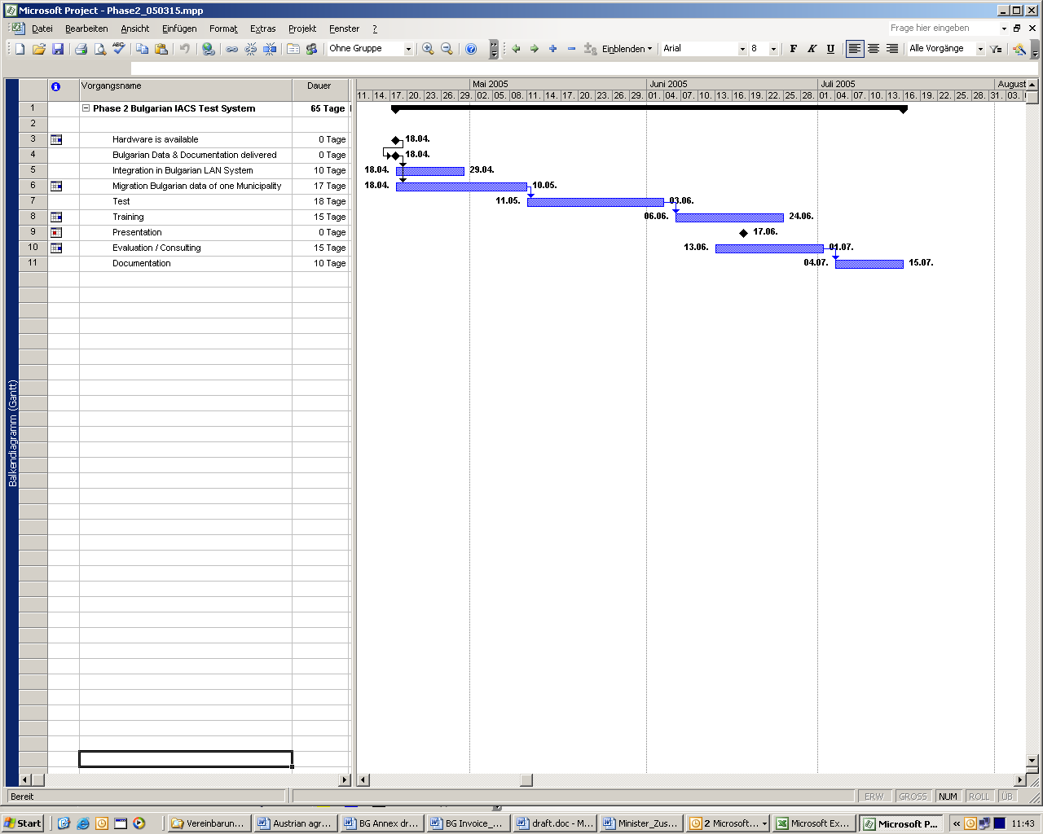

Summary Phase 2:
195 expert days at € 850 each = € 165.750,00 (139 days in Sofia)
Expenses: € 37.310,00
TOTAL COSTS
Phase 1 incl. expenses | 84.800,00 EUR
Phase 2 incl. expenses | 203.060,00 EUR
Hardware | 76.000,00 EUR
Software Licences | 35.399,00 EUR
Total | 399.259,00 EUR

All prices above do not include taxes/VAT
The work will be accounted in accordance to the effort made.

All financial transaction according to this document should be paid into the bank account indicated hereafter:
Bank name: Bank Austria Creditanstalt AG Branch address: Schottengasse 6-8
Postcode: 1010 Town/City: Wien
Country: Austria

Account number: 696172600
BIC: BKAUATWW
IBAN: AT091200000696172600
List of activities of Bulgarian experts during phase 2

Ad (a)
Installation of the system in the Bulgarian LAN
Internet infrastructure and connection of the SFA (Ministry and regional site)

Ad (b)
Provision of the documentation of the structure and description both of the geo-data and the alphanumerical data (registers).
Provision of the data according to schedule or earlier

Ad (c)
Working places with development environment integrated into the SFA LAN (Internet, database) for 4 experts (1 operative, 3 IT) 7 days before Sofia

Ad (d) Presentation has to be prepared and made by Bulgarian experts (all).

Ad (e)
3 – 6 experts for training
1 – 2 specialist(s) Animal Register, 1 – 2 specialist(s) Area Register / GIS, 1 – 2 specialist(s) Farm/Farmers Register

Ad (f)
Bulgarian experts who develop the procedures together with the Austrian experts
(3 operative experts, 2 IT/GIS)

