Draft
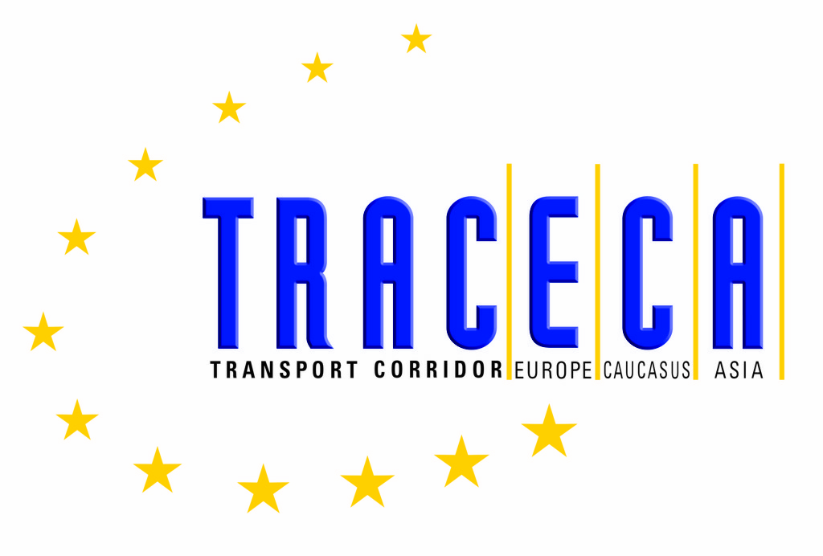

Fourth ANNUAL MEETING  OF THE TRACECA INTERGOVERNMENTAL COMMISSION  Baky / Republic of Azerbaijan, April 21-22, 2005 | ЧЕТВЕРТОЕ ЕЖЕГОДНОЕ ЗАСЕДАНИЕ  МЕЖПРАВИТЕЛЬСТВЕННОЙ КОМИССИИ ТРАСЕКА  Баку / Азербайджанская Республика, 21-22 апреля 2005 г.

PROTOCOL ON AMENDMENTS

TO THE BASIC MULTILATERAL AGREEMENT ON INTERNATIONAL TRANSPORT
FOR DEVELOPMENT OF THE EUROPE - THE CAUCASUS - ASIA CORRIDOR

In accordance with Article 11 (Presentation of Amendments and Additions) of the Basic Multilateral Agreement on International Transport for Development of the Europe - the Caucasus -Asia Corridor (Basic Agreement) it was agreed to incorporate the following additions to the Technical Annex on Customs and Documentation Procedures to the Basic Agreement:

1. Supplement the Article 2, clause 1, “International Conventions” with new sub-clause with the following content:

d. International Convention on the Simplification and Harmonization of Custom Procedures 1973, as amended;
e. Convention on custom treatment of pools containers used in International transport 1994;
f. Agreement concerning the establishing of global Technical Regulations for Wheeled Vehicles, Equipment and Parts which can be fitted and/or be used on Wheeled Vehicles 1998;
g. United Nation Convention on the Liability of Operators of Transport terminals in International Trade 1991.

2. Supplement the Article 3 “Customs Control” with new clause stipulated as follows:

“3. Provided that the applied procedures for transit operations are fulfilled in accordance with the requirements of the customs’ legislation of the relevant state, in this case, goods in international transport including transit:
- shall not, as a general rule, be subject to customs examination during the journey except to the extent necessary to ensure compliance with rules and regulations which the relevant customs administration is responsible for enforcing. Flowing from this, the customs authorities shall normally restrict themselves to the control of customs seals and other security measures at points of entry and exit;
- shall not be subject to any customs formalities or requirements additional to those of the customs transit regime used for the transit operation.”

3. Supplement the Technical Annex with a new Article stipulated as follows:

“Article 5
Transit Facilitation
In order to facilitate the transit of goods, the Party shall:

a. if it is the country of shipment, as far as practicable, take all measures to ensure the completeness and accuracy of the information required for the subsequent transit operations;
b. if it is the country of destination:

- take all necessary measures to ensure that goods in customs transit shall be cleared, as a rule, at the customs office of destination of the goods;
- endeavour to carry out the clearance of goods at a place as near as is possible to the place of final destination of the goods.”

This Protocol comes into force in accordance with Articles 11 (“Presentation of Amendments and Additions” and 13 (“Entry into force”) of the Basic Multilateral Agreement on International Transport for the Development of the Europe - the Caucasus - Asia Corridor.

Done on the 4th Annual Meeting of the TRACECA Intergovernmental Commission on the transport corridor Europe - the Caucasus - Asia at Baky on 21 of April 2005 in one original copy in the English and Russian languages, both of them being equally authentic.

In witness whereof, the undersigned plenipotentiary Heads of Delegations have signed this Protocol.

For the Republic of Armenia | For the Republic of Moldova
For the Republic of Azerbaijan | For Romania
For the Republic of Bulgaria | For the Republic of Tajikistan
For Georgia | For the Republic of Turkey
For the Republic of Kazakhstan | For Ukraine
For the Kyrgyz Republic | For the Republic of Uzbekistan

